**Installation of wireshark**

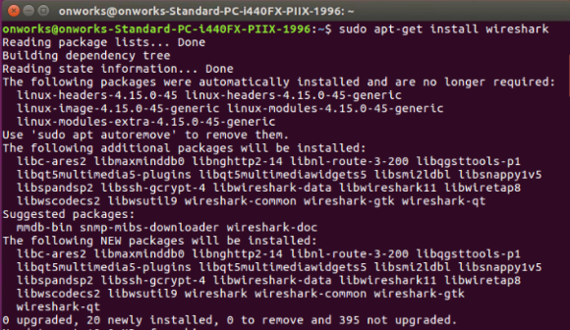

**Running wireshark**

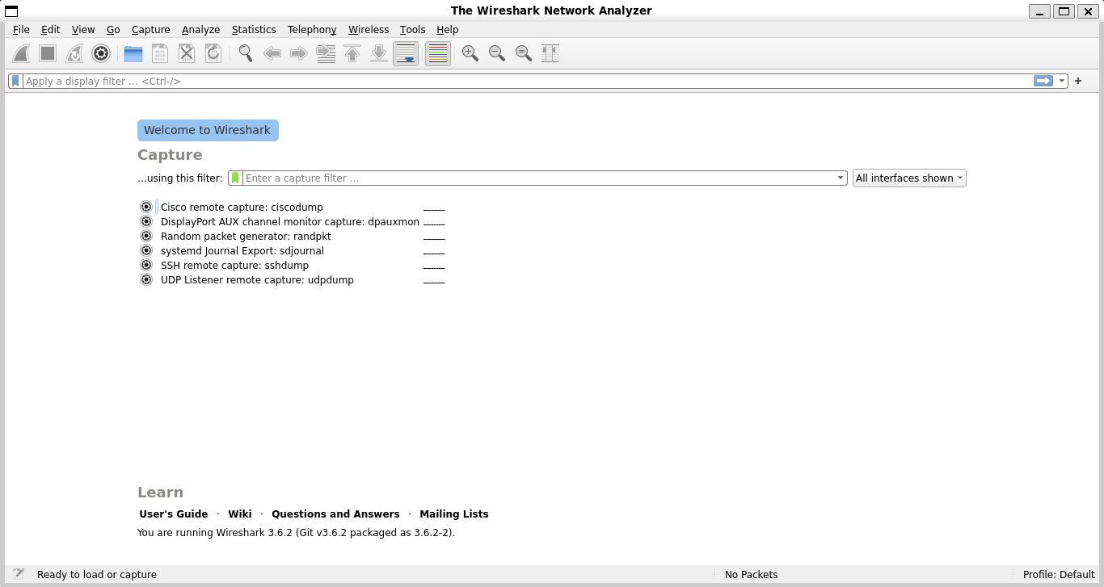

**Wireshark Packet Capturing Interface**

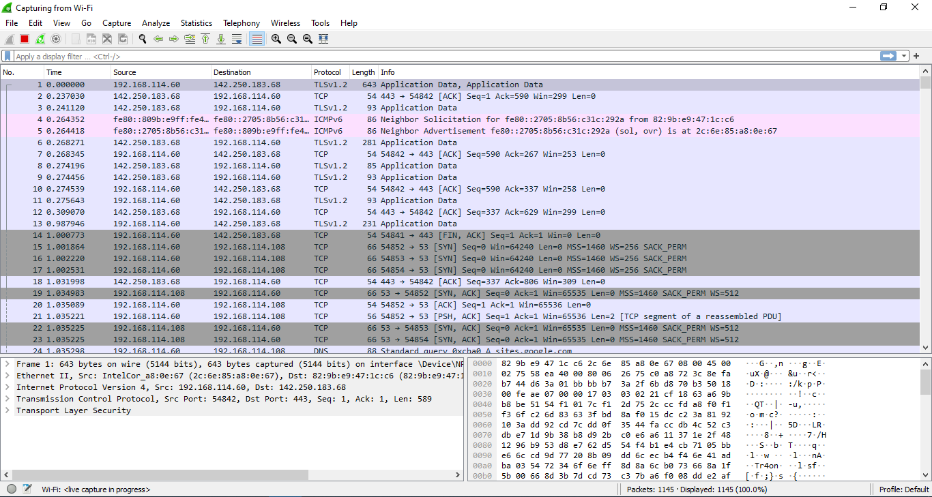

**Capturing HTTP GET Requests**

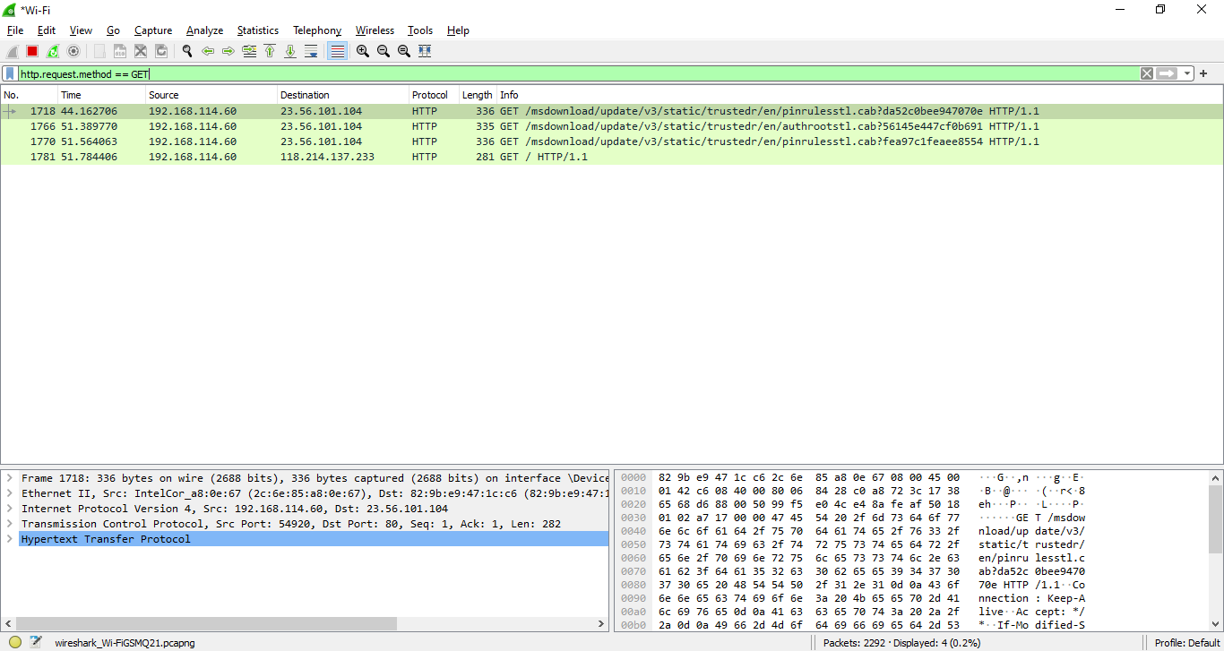

**Capturing HTTP Response**

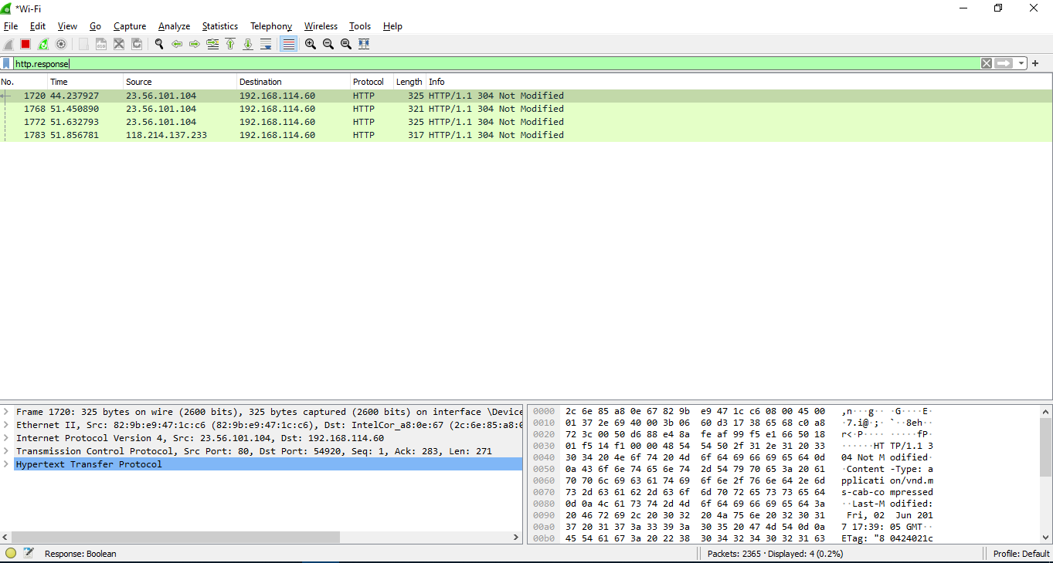

**Capturing DNS Packets**

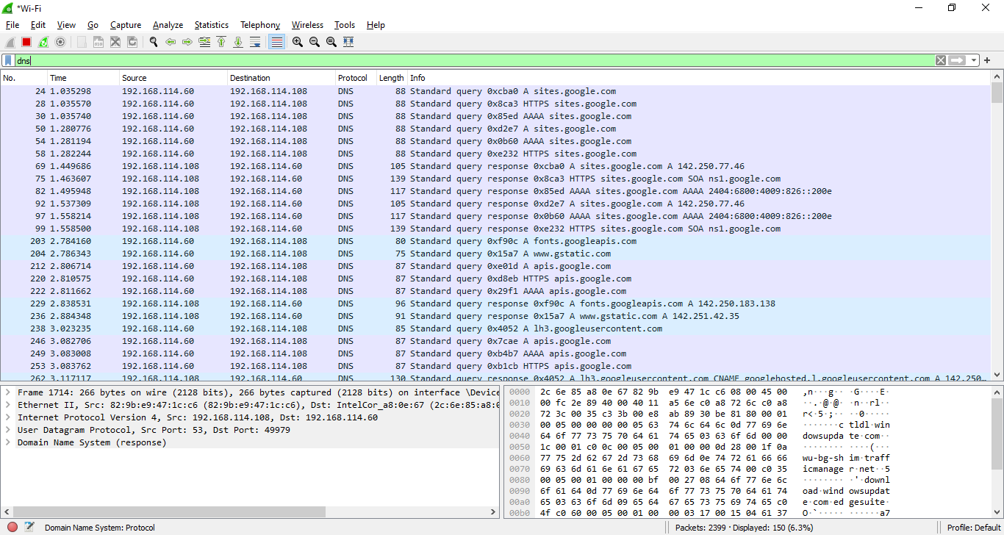

**Capturing TCP Port 80 and UDP Port 80**

